**Exercise 3: Stored Procedures**

CREATE TABLE customers (

customer_id INTEGER PRIMARY KEY,

name VARCHAR(50),

age INTEGER,

balance NUMERIC(12,2),

isvip VARCHAR(5)

);

CREATE TABLE loans (

loan_id INTEGER PRIMARY KEY,

customer_id INTEGER REFERENCES customers(customer_id),

interest_rate NUMERIC(5,2),

due_date DATE

);

CREATE TABLE employees (

employee_id INTEGER PRIMARY KEY,

name VARCHAR(50),

department_id INTEGER,

salary NUMERIC(10,2)

);

CREATE TABLE accounts (

account_id INTEGER PRIMARY KEY,

customer_id INTEGER REFERENCES customers(customer_id),

account_type VARCHAR(20),

balance NUMERIC(12,2)

);

INSERT INTO customers VALUES (1, 'Alice', 65, 15000.00, 'FALSE');

INSERT INTO customers VALUES (2, 'Bob', 45, 9500.00, 'FALSE');

INSERT INTO customers VALUES (3, 'Charlie', 70, 12000.00, 'FALSE');

INSERT INTO customers VALUES (4, 'Diana', 30, 10500.00, 'FALSE');

INSERT INTO loans VALUES (101, 1, 8.5, CURRENT_DATE + 10);

INSERT INTO loans VALUES (102, 2, 7.9, CURRENT_DATE + 40);

INSERT INTO loans VALUES (103, 3, 9.0, CURRENT_DATE + 5);

INSERT INTO loans VALUES (104, 4, 7.5, CURRENT_DATE - 3);

INSERT INTO loans VALUES (105, 1, 8.0, CURRENT_DATE + 20);

INSERT INTO employees VALUES (201, 'Ravi', 10, 40000.00);

INSERT INTO employees VALUES (202, 'Neha', 10, 45000.00);

INSERT INTO employees VALUES (203, 'Anil', 20, 50000.00);

INSERT INTO accounts VALUES (1001, 1, 'SAVINGS', 5000.00);

INSERT INTO accounts VALUES (1002, 2, 'SAVINGS', 3000.00);

INSERT INTO accounts VALUES (1003, 3, 'CURRENT', 8000.00);

INSERT INTO accounts VALUES (1004, 4, 'SAVINGS', 2000.00);

**Scenario 1:**

**Scenario 2:**

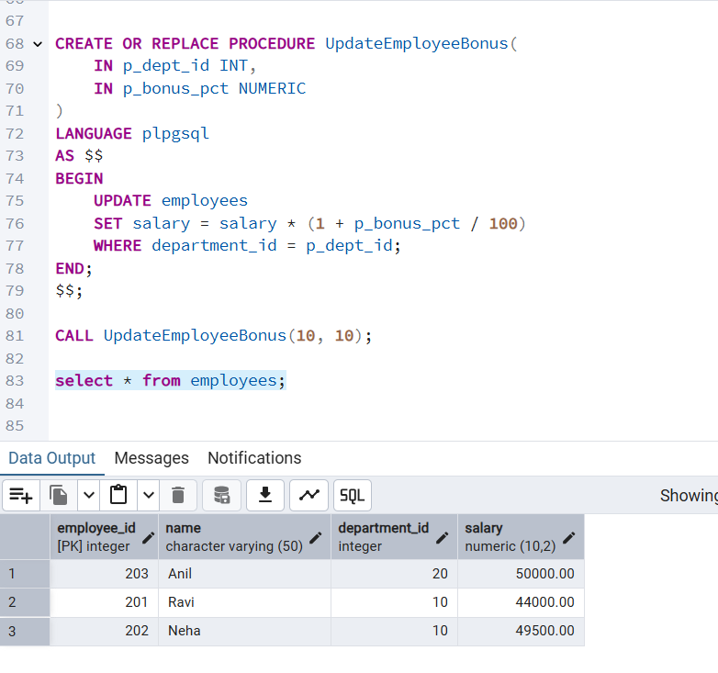

**Scenario 3:**

CREATE OR REPLACE PROCEDURE TransferFunds(

IN p_from_acct INT,

IN p_to_acct INT,

IN p_amount NUMERIC

)

LANGUAGE plpgsql

AS $$

DECLARE

v_balance NUMERIC;

BEGIN

IF p_amount <= 0 THEN

RAISE EXCEPTION 'Amount must be greater than zero.';

END IF;

SELECT balance INTO v_balance FROM accounts WHERE account_id = p_from_acct FOR UPDATE;

IF v_balance < p_amount THEN

RAISE EXCEPTION 'Insufficient balance in source account.';

END IF;

UPDATE accounts SET balance = balance - p_amount WHERE account_id = p_from_acct;

UPDATE accounts SET balance = balance + p_amount WHERE account_id = p_to_acct;

END;

$$;

CALL TransferFunds(1001, 1002, 1000);

select * from accounts;

